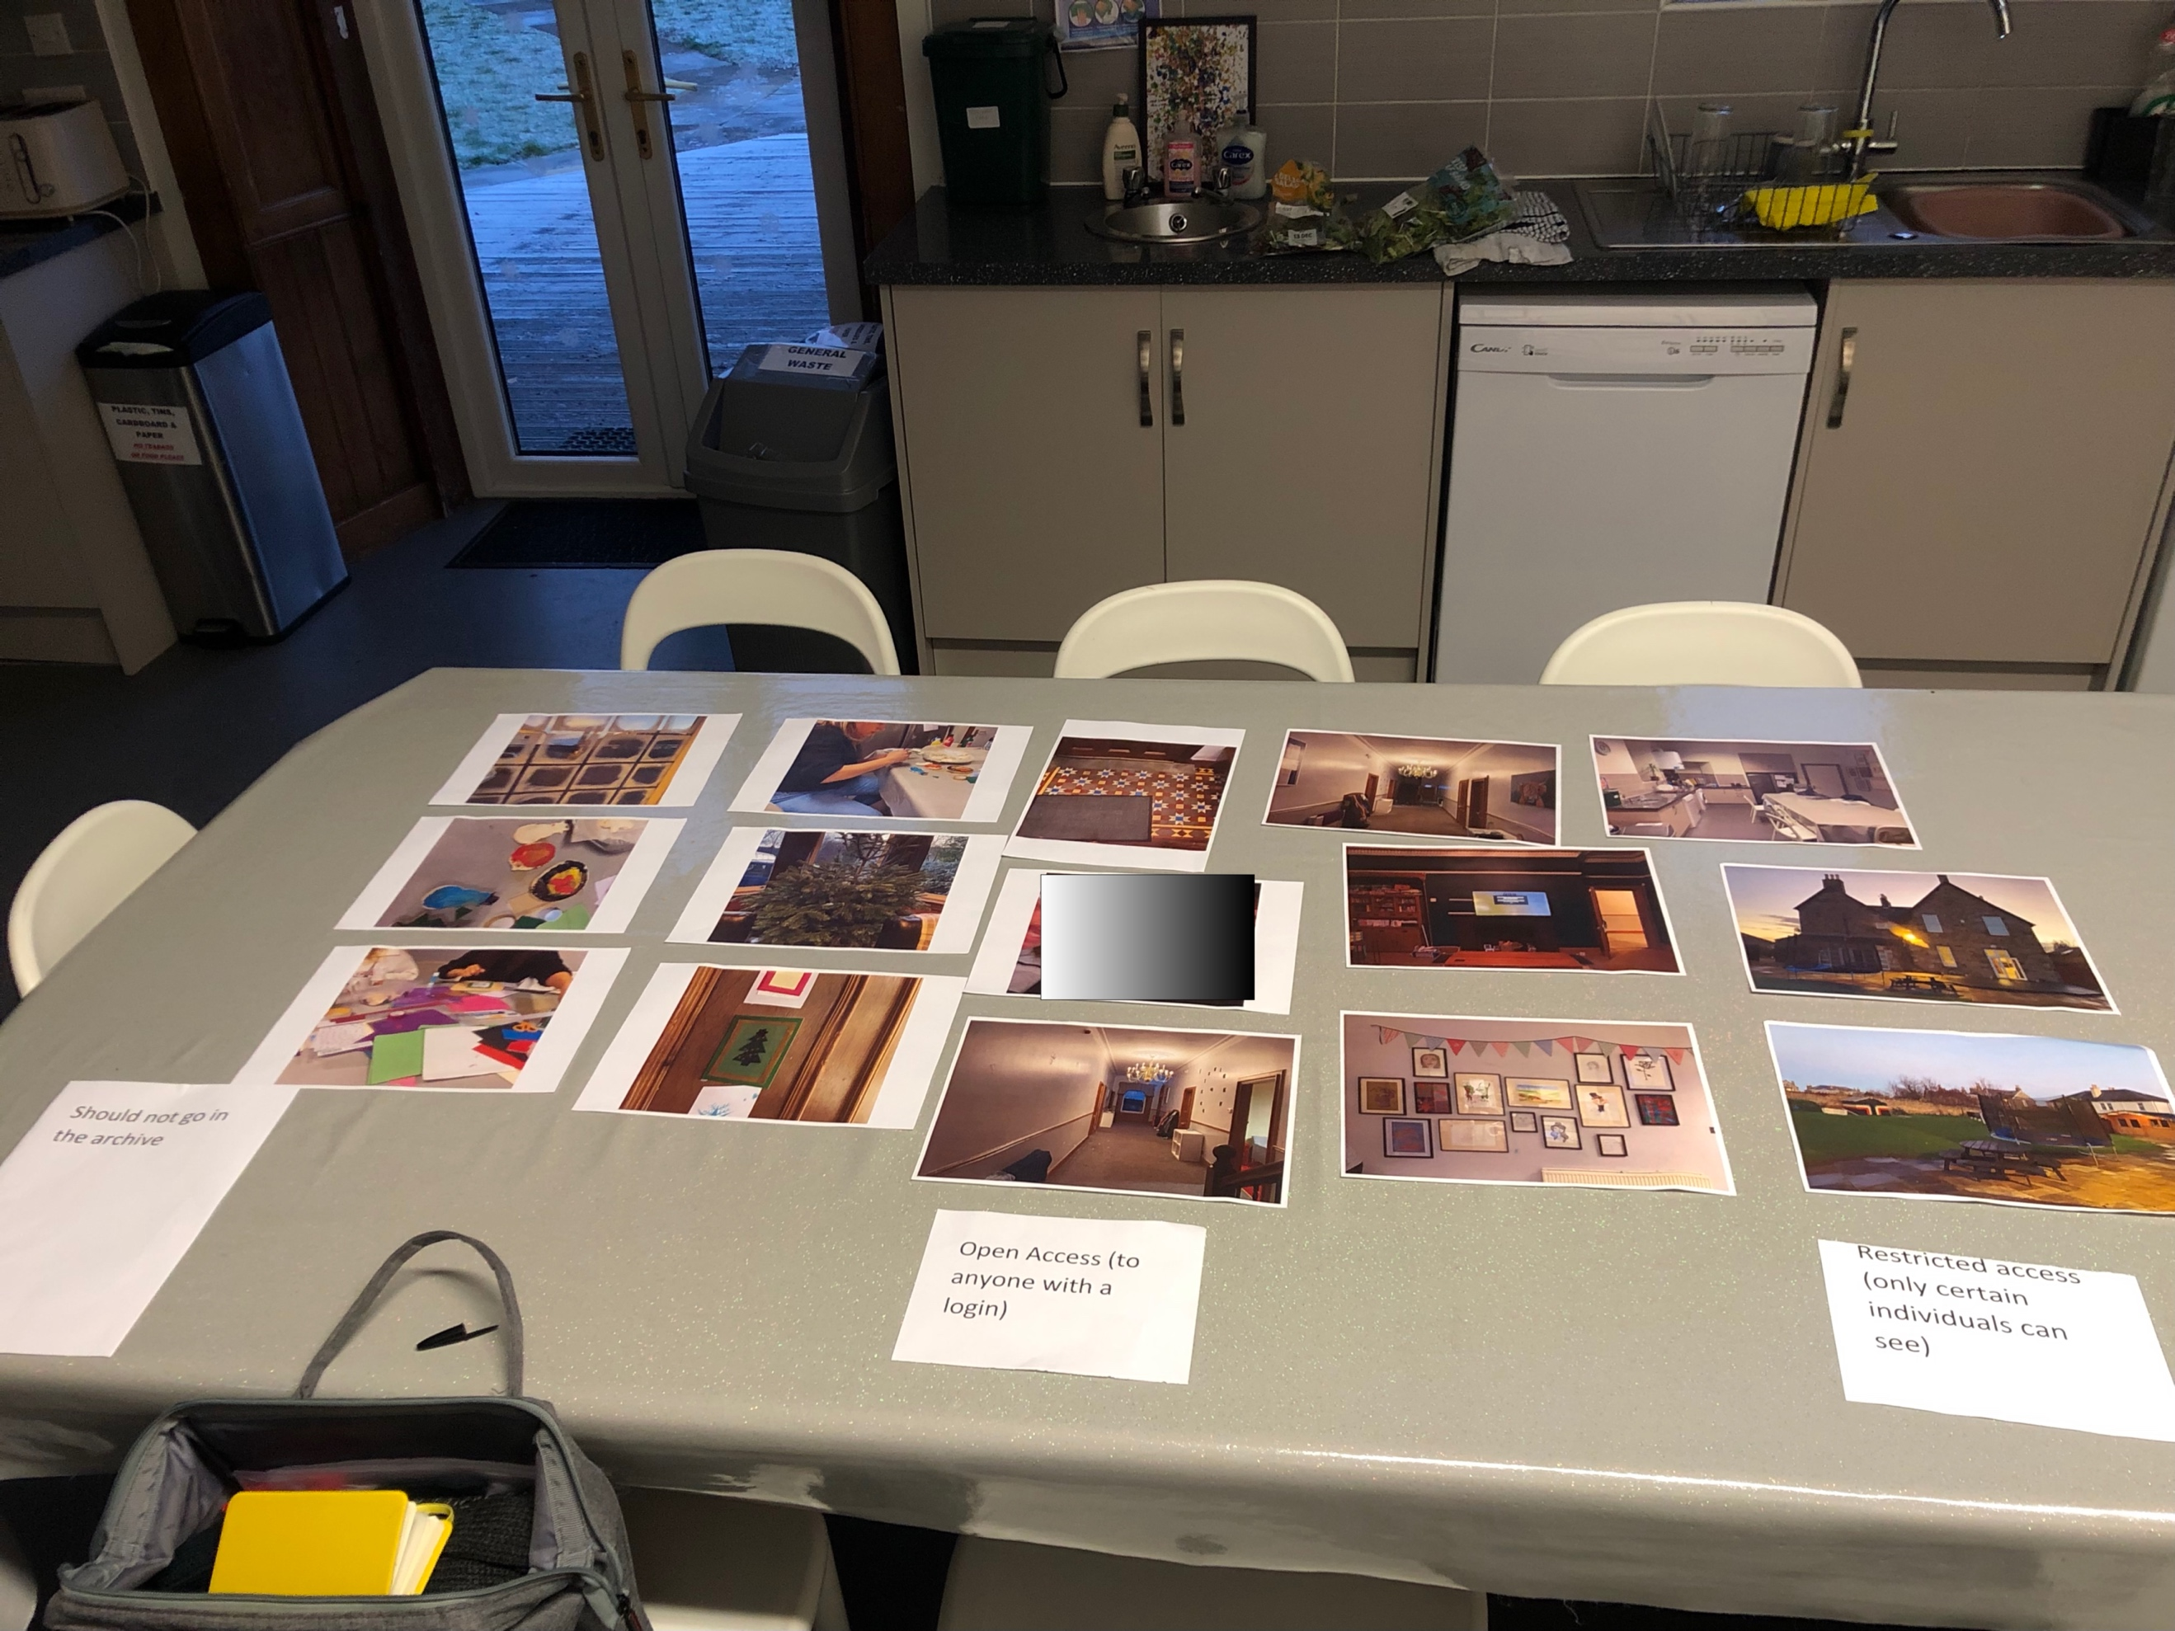

Transcript from Meeting with C and M on 13/12/22

Andrew: I’ll start it…

C: Me and K’s photo man!

Andrew: I know, you must’ve been practicing with the phone or something like that, but I left it in for a good reason and I’ll tell you about that in a minute… erm, so Malta that was here from Germany a few weeks ago, he’s doing the IT and he’s come back and he’s, they want to make something new rather than use Facebook or Instagram or something like that because we don’t know if it will still be here in 10 years yeah?

C: ok

Andrew: so, what he’s saying is [hello – S popped her head round the door and quickly left] he can make something where, basically, everyone who lives here or works here could have a login for, say it’s a website, and so when you log in, there will be a bit where everybody can access a particular bit and then there will be another bit where you access things that are attached to your login…

C: yeah, ok

Andrew: so there’ll be content that is attached to you or that’s relevant to you… but we’re not quite sure how that will work, whether that means your login, does that mean you only get to see pictures you’re in, or can you get to see picture from the time that you lived here, can M see pictures from today given that he doesn’t live here now, you know, we’ve still got all of that kind of stuff to work out. So, I guess the three things that I’ve put there are stuff that should not go in the archive. That could be things that you think ‘why would you put that in, that’s rubbish’ or ‘I don’t think that should be in an archive at all’; and then, if stuff that could go in whether you think it would be alright for it to be in the open bit where anybody can see it, or whether you think it should be in the restricted bit where only certain folk can see it. So that’s basically it. I don’t know what you think about that idea for the archive, that separation, do you think that’s a good idea or…?

C: aye, I do
[M nods]

Andrew: Are there any of these, I guess, for me, I was taking pictures of the house I was thinking that’s probably for the open bit, like anyone who has lived or worked here could go in and see that, I don’t know what you think?

C: yeah, aye, that could definitely be somewhere

Andrew: so you think, like pictures of the house like that [points to picture]

C: aye

Andrew: pictures of the kitchen, rooms yeah?

[C and M nodding]

Andrew: and I’ve got some videos as well. You could do a video run through, you know, you could start out the front and you could do a run through where you come right through and out, you could cut it together you know? It doesn’t need to be pictures I guess

C: aye

Andrew: you could have other, you could have other content in there. What about this one. So, this is a picture of these pictures [indicating drawings on the wall behind] and I don’t know how I feel about that because, although it’s part of the building, these are particular peoples’ pictures, I don’t know whose pictures they are, but…?

C: No, that could definitely go in the open bit as well yeah.

Andrew: you think that could go in the open bit? Do you think anybody who has painted any of these pictures might have a problem with that?

C: No,

Andrew: you don’t anticipate them having any issues with that? No, ok… and, because they’ve been up here on display, anybody who is coming in and out could see them anyway I guess?

C: aye

Andrew: yeah, ok. Well, what about these ones then with people in them? So, obviously this one definitely shows you (C) and K’s face…

C: aye [laughing]
M: [laughing]

Andrew: [laughing] so, you might think ‘I don’t want that in the archive at all’ [laughing] yeah?

C: [laughing] I’m not bothered

Andrew: you’re not bothered… but, even if, that might be the thing… so, that’s the thing I was going to ask about consent. So, if it was to go in, it would need you to agree to it and K as well to agree to it and then… I mean, there are things you can do with pictures if one person agrees and one person doesn’t… have you seen anything like that, where maybe somebody is blurred out?

C: I would only maybe say, like, I don’t know, maybe if like [Ce] is a bit like that, so maybe sometimes she doesn’t like her photos on stuff and [B] may be like that but cause their not in them, not really, no.

Andrew: so, we might have the, well I think, Malta thinks we can have the option, like, say for example you say ‘aye I’m fine for my pictures to go in’ and then a bit later, maybe when you’re, I don’t know, 26, you come back and you say ‘you know what, I’m actually not alright with that, gonna get me out of them’? And he can do a thing where you’re blurred out of every picture that’s on there…

C: ah, I get it, aye

Andrew: We’re trying to think about your consent. You might give it and then you might take it away. Just because you agree for something to go in from the start doesn’t mean that it needs to be there for ever. You could change your mind. Same as if you’d said no and then decide later ‘actually, I do want they pictures to be in there’ as well so you change that. So, if that [picture] was to go in then, say this one with you and [K], do you think it can go in open access?

C: yeah, aye

Andrew: you think it could? You wouldn’t mind anybody seeing that?

C: No, I would only maybe say photos, like silly ones, or like nice photos can go in open access but maybe, like, I don’t know, we were doing something that has private stuff on it. So, say maybe, like, I don’t know, maybe there’s like a photo of us doing work or something, maybe that could go in the other one… but anything where you’re taking nice photos you can see with your login [meaning open access].

Andrew: Ah, so it’s the nature of what you are doing in the picture then?

C: Aye, aye.

Andrew: ok, so if it’s, like, erm, doing the World Cup Sweep

C: Aye

Andrew: Something like that, you’d be comfortable with it being open?

C: And if there’s a nice photo of us together or something… but, if it was something like we were doing that’s, I don’t know, a bit more private I we had a photo of us, I don’t know, maybe not, maybe it would just go into the private bit, but it would still be on there.

Andrew: yeah

C: Only certain individuals can see it or something.

Andrew: Cool… and, erm, what do you think [M]? How would you feel if I had a picture of you here? How would you feel about it being, if, like, say I worked here and I logged in, I could see your picture, would you be alright with that or would you want that to be in the restricted thing? You would want more restrictions yeah?

M: [mumbling and nodding]

Andrew: So, if that was you and K then, and it was in the restricted

C: [to M, laughing, saying something about K taking photos]

Andrew: and it was in the restricted section, would you want it to be just you and [K] who could access that picture because you’re the only two folk in it, or would you want, like, you and [K], and maybe [C] and [B], folk you knew to have access, or would you want it to be just you and K?

M: [inaudible]

Andrew: you’re not sure?

C: [to M] So, open access one then? Aye.

Andrew: So, bearing in mind, so if this archive lasts, say this archive lasts for the next 20 or 30 years for FF House, obviously you’ve moved on [M], but you’ll have moved on, you’ll be away, there’ll be new folk here who you don’t necessarily know would you still be alright with them seeing your picture…

C: aye

Andrew: would you prefer it to be kept within…

C: I wouldn’t mind

Andrew: you wouldn’t mind?

M: don’t know

C: he just doesn’t care [laughing]

Andrew: [to M] you’re not that bothered either way? Erm, fair enough! What do you think about the whole idea, cause I’ve not had a chance to ask you that [M], what do you think about the whole idea of keeping an archive, where you could log in at some point and look at photos from here? Would that be something you would use or do you think, ach, that’s pointless? I would just look at my Facebook, or…?

M: I wouldn’t really take photos of myself.

Andrew: Yeah? You’re not sure if you would use it? Yeah? No convinced? That’s fair enough, I’m not offended by that at all. Might there, so there might be some types of pictures where you might want them to be more restricted and you [C] said that would be about the type of activity or if you were doing something more private?

C: uhuh

Andrew: And you said something as well, so if it’s a nice picture or you’re doing nice things as a group and, what I’m conscious of is that the archive is going to be for you guys and no everything that happens here is necessarily nice [laughing]

C: yeah [laughs]

Andrew: you know, that’s not how life is.

C: no

Andrew: and so, sometimes, in archives like this, particularly for, like, children’s homes and things like that, they could, some people might argue ‘oh you’re sugar-coating it; you’re making it look like it was a lovely nice place, that it was always great and actually, you know, I had quite a hard time there’. So, we’ve looked at the Aberlour archive from 1920 to 1980. You know, the old orphanage and that up in Aberdeen? And they had a magazine, the blue, I’m trying to remember the Aberlour, it was a blue covered magazine and they, the organisation produced it. But see the folk that used to live in the orphanage, the called it the Blue Liar cause they said it, they just, they just put these stories in

C: aye

Andrew: about all the nice things that went on. They didn’t talk about the fact they made us clean all the time, or they didn’t talk about this… and so I’m wondering then, do you think the archive should include, like, a range of things including things that maybe are, like stories or…

C: stories, aye. I wouldn’t like have, like, bad events. But maybe, like, obviously, stories and that but nothing like, because, like, you’d never be able to see that. So, like if somebody had a bad event and they didn’t want to be in it, they’d never be able to see it whereas, I don’t think people would want them in, like, in open access ones eh?

Andrew: Yeah, ok. Certainly not in open access but you…

C: It might be for that one person who wants to look back on it.

Andrew: Yeah. The other thing is, people don’t always have the same experience of an activity. So, for example, I’ve got some pictures here of, say, making the Christmas stuff yeah?

C: Yeah

Andrew: So, say some of the folk who were involved in that really enjoyed it but, say you really hate Christmas [laughs] and you hated that and they made you, ‘I felt like you made me do that and I didn’t have a good time’… Would you want the ability to comment on things, on pictures if they were up, like if you’d seen a picture and I’d written ‘Oh, I loved that trip to Burntisland’, would you want the ability for you to say ‘oh did you? I thought it was really boring’… would you want that ability to comment on things?

C: aye

Andrew: would you like that [M], although you were saying you might not use this, would you like the ability to comment? Yes, you would [responding to his nodding]. OK. So, sorry I’ve got lots of questions while I’ve got you here, I won’t be too long honestly… What about, so these are things I’ve taken, what about, would you, would you want the ability to upload stuff yourself or would you want the staff to do that or…?

C: The staff to do it probably.

Andrew: You’d want the staff to do it for you? And would you, would you want them, would you be happy with them uploading stuff if they’ve got, you know, if they’ve generally asked you ‘are you alright if I upload things to the archive’ or would you want to be able to check each thing that they are uploading so that you know what’s up there, going up there in the first instance?

C: I wouldn’t want asked every time but, like, maybe if there’s one where, I don’t know, if I was doing something like I wasn’t, like I wasn’t enjoying it or, I don’t know. It maybe, I don’t know… Nah, I would be alright, I wouldn’t need, if I’ve said it would be able to go on there, I would be fine with it.

Andrew: Cause, I know, I know, for example, you’ve got a memory book, is that right?

C: Aye.

Andrew: Aye, so you put stuff into that yourself don’t you?

C: I gave photos to the staff and they stuck it in.

Andrew: Do they put stuff in that as well for you?

C: Yeah

Andrew: And then you see it when it’s in, and that’s been alright? Do you see it [this archive] in a similar way to that?

C: Yeah yeah yeah

Andrew: What about you [M]? Would you be happy if folk were uploading pictures of you or would you want them to check with you each picture?

M: I wouldn’t mind

Andrew: You wouldn’t mind? Interesting, ok. I mean, I suppose there’ll be an option if you’re looking at the archive and you were like that ‘oh I’m not happy with that’, to be able to say ‘I want that one taken down’ or something like that.

C: If I didn’t like it, I’d be able to just text them and say ‘gonna get that down please’? That kinda thing? That’s the only option really.

Andrew: Yeah, yeah, so you’d need a process that you know that ‘I can email them or text them’ or something like that and then, erm, get that down. Good, let me check and see if I had another question [checking notes]… ok, that’s fine. Aye! So, is there anything then, so these are just, this is just from a couple of times I’ve been up here, most of them, apart from you and K [both laughing], erm, what’s, what’s missing from here in terms of the kinds of pictures that you would like to see?

C: There’s no many people!

Andrew: That’s, yeah, there’s not many people is there?

C: No.

Andrew: And, I’ve been a bit worried, I guess, maybe I’m overthinking it, I’ve been a bit worried about taking pictures of people because I don’t live here…

C: Yeah

Andrew: It’s no my house

C: No.

Andrew: I’m a bit worried about doing that?

C: No, I don’t think they would be bothered. I mean, I’d be fine with it. [M] doesn’t really mind… [L], I would say [L] is the only one you kinda stay away from with that.

Andrew: I know he plays his cards close to his chest [L]

C: He’d look at you and probably go [indicates surprise/dislike in expression]

[Noise interruption from W who enters the kitchen]

Andrew: I mean the iPhones and the iPad are there for you to use if you do want to take any pictures. I mean, obviously there is going to be a lot of social activities going on over the next few weeks. So, if you do want to take anything that you think may be quite interesting content, then you’re more than welcome to just say to the staff and they’ll give you they phones or whatever else and then I can download it and bring more images up and we can have a look at them and a chat about them or whatever else.

C: aye

[W asking questions about a particular photo, Andrew responding]

Andrew: So, if you do, if there is anything that’s going on that’s really interesting, or things that you think would be… might be good, that you think might be good to go in the archive, then that would be ideal. If you fancy it, you can take they phones or use your own phone or whatever else and we can get a hold of them.

The other thing that we want to do as part of this project as well as things like this, to try and see how to make the archive, is to maybe interview folk about memories and memory-keeping. So, I was thinking, if you were up for it, it would be great to interview you at some point if you were up for it?

C: aye

Andrew: But, I can ask you again at the time and you can change your mind on that, so don’t worry I’ll no, you know me

C: yeah

Andrew: I’m not the kinda person that would try to bully folk or anything into doing anything the don't want to do. But, it would just be, it would be great actually I was thinking if you’d be up for showing me your memory book and me kind of interviewing you about it if you like, so like, asking you some questions about why some pictures and not others…

C: yeah, aye.

Andrew: and other things, if that’s alright with you? We could do that at some point, maybe in the New Year cause I know it’s coming up to Christmas and you’re probably sick of the sight of me by this point [laughing]

C: Not at all, it’s alright.

Andrew: That’s brilliant. Is there anything that you want to ask me about this project or anything like that?

C: He has thousands of questions for you [indicating M] [all laughing]

Andrew: No? Ok, cool. That was really helpful for me, thank you very much. I really appreciate you taking the time to do that.

C: No worries.

Andrew: Thank you. Good to see you as well, and you [M]! Take care of yourself.

