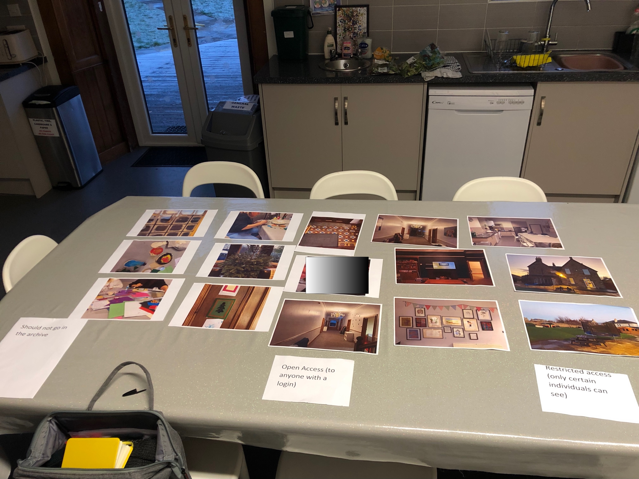

Transcript of meeting with staff (and [young person] who came in later) 13/12/22

Andrew: So, [other researcher] who was here a few weeks ago from Germany. He’s the IT guy and what he’s come back and said is that they are going to make a new thing for this archive because, if they use Facebook, it might not be here in 10 years

STAFF MEMBER 1: aye

Andrew: and you don’t control the data and all of that, so there’s all of that. So, they want to make something and they want it to be free and easy to use, all of that kind of stuff. And, the thing that he’s going to make it’s like, the prototype is going to be like a website, yeah, basically anybody who lives or works at [RESEARCH SITE]

[hiya, feel free to join us – to other staff member who came in: I’ll come and join you just now, I just need to do something first]

Andrew: No worries. So anybody basically who lives or works at [RESEARCH SITE] would get a login. And everybody then, like yourself the weans whatever, would login and there’ll be a bit where, when you login, everybody who has got a login can access it yeah?

STAFF MEMBER 1: Right

Andrew: and then there’ll be another bit, where it will be attached to your login that will be stuff that only you and other folk that are in certain things will see

STAFF MEMBER 1: aye

Andrew: So there’ll be two kinda levels, so, a kind of open access, no open to the public but open to anyone in FF.

STAFF MEMBER 1: No, ok,

Andrew: and then another bit where it’s only things that you can see, that [YOUNG PERSON] can see. So, you’ll have your own bit where there’s content that only you can see

STAFF MEMBER 1: aye

Andrew: so that might be, say there’s pictures of you on a trip with [YOUNG PERSON], only you and [YOUNG PERSON] can see those picture… maybe

STAFF MEMBER 1: aye, maybe… so, you could say that ‘I’d prefer, I’d like that just to go on the open[RESEARCH SITE]one’ that would be fine.

Andrew: Right! So that’s exactly the question, with the restricted access, so that was some of the questions I was asking the young people and I wanted to ask some of the staff what you thought about this. So, I guess when you look at pictures of the house and the garden, there’s no people in these pictures

STAFF MEMBER 1: no

Andrew: but they would be alright for the open access bit?

STAFF MEMBER 1: Yes. Aye, the likes of… I mean that, the kitchen is one of the most important places in this house.

Andrew: Yeah

STAFF MEMBER 1: and this is, the kitchen is the hub of this house because, I mean, like, all through the day, like you’ve got the kids’ breakfast, you’ve got their lunch, ken you’ve got the adults for lunch, adults meeting up. Ken, that’s a good one [picture], just for that, that just says[RESEARCH SITE]to mean, ken the kitchen. And like that aye, and that [indicating two other pictures] cause that’s the kitchen again, in the house.

Andrew: See, this one, that was an interesting one for me. So, I was asking [YOUNG PERSON] and [YOUNG PERSON] about that and, obviously that’s up and it’s on the wall but these are certain people’s pictures, their paintings, their drawings.

STAFF MEMBER 1: aye

Andrew: and I wasn’t sure if, how, could that, they thought that could easily be open but I said, well, what if I drew that picture and I don’t want my painting on the thing?

STAFF MEMBER 1: well, I mean there was [staff member] there was [young person] and [staff member]

Andrew: right

STAFF MEMBER 1: I mean, that was virtually it.

Andrew: So they would probably be alright, you could always…

STAFF MEMBER 1: Can’t remember who drew that. I think that was someone who came in and sat and drew maybe [unclear name]. Aye, but then, I think that’s, that’s a, that is, ken they would see that everyday.

Andrew: Yeah

STAFF MEMBER 1: That’s been the last 2, year and half, two years?

Andrew: ok

STAFF MEMBER 1: and that’s managed to stay up there, so [laughing] it’s good

Andrew: yeah, it’s great, it looks great! So, the other one then is where this is people. So this one here has [YOUNG PERSON]and [staff member] in it, they were messing about with the phone… and I kept that in. So, I was saying, well, we’d need consent from them

STAFF MEMBER 1: aye

Andrew: So, they might say, I’m alright with that, or, I don’t want that photo up, I don’t like that photo or whatever else.

STAFF MEMBER 1: aye… Like, [YOUNG PERSON]was taking my photos last week and I’m like ‘wow, get them deleted’. So I deleted all of them, ken what I mean?

Andrew: aye… [another adult joins the discussion]. So, we’re just talking about different parts of a potential archive where everybody who lives or works at [RESEARCH SITE] could have a login and go in and there’s an open bit, where everybody can see. So we’re saying probably pictures of the house and stuff like that, but there are other ones that might be restricted according to you login

STAFF MEMBER 2: right

Andrew: So, we’re just saying, for example, say this picture here of [staff member] and C, so [staff member] and [YOUNG PERSON] when they log in they’ll be able to see that picture

STAFF MEMBER 2: but I might no?

Andrew: but you might no… but they were saying, what [YOUNG PERSON] was saying was “well I wouldn’t mind anybody seeing my picture”. So, we’re trying to figure out this restricted level – should it be ‘the folk I lived with here at this time but not folk who might live here in 10 years’ time’? Because they never lived with [YOUNG PERSON]and never knew [Young person] , so we’re trying to figure out and I wasn’t sure what your thoughts about that would be because you’ll know this stuff better than me?

STAFF MEMBER 2: Well, I would probably agree with what you were saying, aye, but that might make it difficult as well wouldn’t it?

Andrew: Well, that’s what were in this for isn’t it? It is tricky?

STAFF MEMBER 2: And, aye, I was going to ask you because [Young Person] was telling me that there were rules about these pictures that we were taking on the phones and there weren’t to be faces and that… is that right?

Andrew: Well, I think what’s she’s taken that from was last week I came up and they were making Christmas decorations and [YOUNG PERSON]was interested in the phone and I said ‘aye, you can take some pictures if you want but just mind if you’re taking picture of folk, just to ask them’

STAFF MEMBER 2: oh, right ok

Andrew: so, she’s maybe taken that

STAFF MEMBER 2: aye, because she’s doing a nursery placement and I think she’s taken it like that because they’ve not to take photos, or take photos of the backs of the children’s heads and that and I was like… riiight.

STAFF MEMBER 1: Aye, but then, if this is going to be the [RESEARCH SITE] site

Andrew: Aye, so this is the thing… There’s no a lot of people in these pictures and the reason for that is I’ve been taking the pictures, and I don’t feel comfortable taking pictures of folk here because I don’t live here and I don’t work here

STAFF MEMBER 2: aye, aye
STAFF MEMBER 1: aye

Andrew: so, I feel quite…

STAFF MEMBER 1: I mean we’ve got loads, we do, I mean all the kids have got load of brilliant photos eh?
STAFF MEMBER 2: aye

Andrew: So, it doesn’t need to be, I mean [staff member]says she’s got some from Halloween and all of that, so there’s lots of stuff that you can use.

STAFF MEMBER 1: We’ve even got the lockdown ones, I mean, 2020 was just amazing wee folder we got. We made a beautiful book eh?
STAFF MEMBER 2: aye
STAFF MEMBER 1: Our 2020 book.

Andrew: So, the thing then to think about for that, because these are just examples to get the conversation going. You could use photos from the past, stuff you’re doing now, stuff that you’re doing in the future and then, I guess, it’s to trying and think about the consent processes and stuff like that. You know, about whether you have a general consent… the impression I get from the young people is that they want the adults to do this for them.

STAFF MEMBER 1: aye
STAFF MEMBER 2: oh, aye

Andrew: And that’s fair enough, that would happen in families

STAFF MEMBER 2: yeah, yeah, that’s fine aye
STAFF MEMBER 1: aye, aye

Andrew: and I know that yous do this stuff anyway

STAFF MEMBER 2: aye

Andrew: you do the memory books, you put the photos up, you do the books

STAFF MEMBER 2: aye, we do the books and that

Andrew: and the daily diaries, you do all this record keeping, this memory keeping

STAFF MEMBER 2: yeah

Andrew: you do the pen drives, and you do it whether the children ask or not, because you know that they might want it in the future even if they say that the won’t

STAFF MEMBER 1: aye, aye

Andrew: So, I know that you are doing all of this stuff anyway, so you’ll have loads of stuff that can go in here. [YOUNG PERSON] was very much of the opinion, he said ‘oh, you don’t need to check every photo by me’ you know, as long as there’s a process where if he’s sees something on it he can say ‘gonny take that down’. So, he was happy with that

STAFF MEMBER 2: aye, aye
STAFF MEMBER 1: aye

Andrew: So, I’ve been thinking about whether you would need to check every photo past everyone who was in it, or whether you could have a general consent ‘I’m happy to be involved with the archive’ kind of thing…

STAFF MEMBER 1: and then, if you do log on, and you see something that you don’t want there “right, can I get that taken down”

Andrew: aye… and the other thing, [other researcher] said that he thinks, once we’re putting them up with a note of who’s in the picture, that he can use technology, facial recognition technology, so if somebody phones up and says “I don’t want my photos up” and there’s lots of group photos with them in, he can blurr them out of the picture so you don’t have to remove the picture.

STAFF MEMBER 1: do you think he could do wedding photos of mine! [laughing]

Andrew: so, you’ve got a group picture and one person doesn’t want their picture up but everybody else is alright

STAFF MEMBER 1: aye, aye
STAFF MEMBER 2: aye

Andrew: that can be an issue because everyone else is like “no, I want that picture up, that was a great party”

STAFF MEMBER 1: aye
STAFF MEMBER 2: aye, aye

STAFF MEMBER 1: and like, we had our 10-year anniversary

Andrew: I was here, the open day?

STAFF MEMBER 1: Aye, aye. I mean, that, to me, that was just a great [RESEARCH SITE] day
STAFF MEMBER 2: Yeah
STAFF MEMBER 1: It was really quite… I’ve never seen it quite so easy. That sounds really… ken, but for the amount of adults that were here and even for all the kids from the other houses, it was really quite smooth and easy

STAFF MEMBER 2: Aye, it was smooth

Andrew: aye, it was nice when I was here… I went away with a big eye drawn on my head!

STAFF MEMBER 2: aye, but sometimes it does go a wee bit skew-wiff when you’re with other kids there

STAFF MEMBER 1: even with our own kids!

STAFF MEMBER 2: aye, even with our own kids it can go…

STAFF MEMBER 1: it can go, and it’s…

STAFF MEMBER 2: I love that photo of the house by the way [indicating a picture on the table]. That’s a great photo, aye.

STAFF MEMBER 1: I like that one, that’s, that’s the kitchen and that’s the hub of here eh?

STAFF MEMBER 2: aye, it is.

STAFF MEMBER 1: it is, it is… it’s just the hub

Andrew: you could get, I mean that’s all my stuff in that, but you could get better ones as I say, these are just examples, it’s just to try and have something concrete to talk to the young people, ‘what do you think about this and what do you think is missing’? And they said, people! That’s what’s missing!

STAFF MEMBER 1: Aye

Andrew: So, I’ve said to them ‘the phones are there if you want to take more content, you’re more than welcome to use them to get more people that you want’.

STAFF MEMBER 1: Aye, cause, like, the kitchen’s never empty is it?

STAFF MEMBER 2: There’s always someone in here

STAFF MEMBER 1: Always someone in the kitchen

Andrew: and I got video stuff as well. I got video of R and [YOUNG PERSON] playing football at night before and I did a bit of a garden sweep and all of that kind of thing. You could do a run through in the house

STAFF MEMBER 2: Aye, yeah

Andrew: So, for somebody who has not been here for years, that’s in their 20s or in their 30s and maybe showing their own weans ‘this is where I used to stay’

STAFF MEMBER 1: aye

Andrew: This is, these are the people that looked after me when I was wee.

STAFF MEMBER 1: aye

Andrew: To have that as a resource where you don’t have to come and ask

[others enter the kitchen and some conversation takes place between everyone]

Andrew: where you don’t have to come and ask, you just log in when it suits you and you might want to access your records and you might no. But this is something you can just go and see if you wanted to. That’s the kind of thinking behind it you know.

STAFF MEMBER 1: aye

Andrew: and we don’t know. This is a prototype, this has never been done before. It’s happening here in [RESEARCH SITE] and it’s happening in one place in Germany at the same time and that’s it, we’ll see where we’ll get to. We don’t know if it’s going to work or how it’s going to go…

STAFF MEMBER 1: aye, well, remember I was telling you I was meeting up with that young lassie that had left the care services?

Andrew: yeah, yeah

STAFF MEMBER 1: I met up with her and wow! Wow, see the memories that she… I mean, she brought her 1yo daughter down. She’s 26, she drove down from [a city] and so… so, really confident and then she started touching on ‘well I think this, and I think that’ and I’m like that ‘well things change, things have changed’ in the last 10 years. And, ken, like, about the no holds and about how we’ve got a 9yo in with a 20yo and ‘that’s wrong’ and I went, ‘hows that wrong?’ because at her time, it was all age, they were all the same age

Andrew: that’s no how a family is, is it?

STAFF MEMBER 2: No it’s not, I said that, you’re totally right .

STAFF MEMBER 1: I said that’s no what a family is like and she went ‘it must be weird’. Ken, it’s different!

Andrew: it can be tricky [laughing]

STAFF MEMBER 1: I says it’s different, but we just have to get on with it. And she was like ‘wow’…. And it was really good seeing her and quite positive.

Andrew: did she used to stay here?

STAFF MEMBER 1: No. She stayed at [another place].

Andrew: It’s one of the things I’d be interested in, [Young person] has been involved but, I think you get a different perspective once you’re 26, or 28, or 30

STAFF MEMBER 1: aye

Andrew: about the things that you want. I think when you’re 16 or 17 or 18, you’re looking forward you’re not looking back

STAFF MEMBER 1: Aye. I mean, like, because this is a young house eh?

STAFF MEMBER 2: aye

STAFF MEMBER 1: I mean, this is only 10 years in service

Andrew: that’s right, aye

STAFF MEMBER 1: So, it’s quite young whereas [another service] has been in service for what 26 years?

STAFF MEMBER 2: 20-odd

STAFF MEMBER 1: 20-odd years

[Young person (16yo) enters kitchen and is looking at the pictures]

Andrew: No, it’s alright – you’re welcome to join us if you would like?

Young person: Just walk in and start chatting and stuff?

Andrew: We’re just talking about this archive. We’re thinking about a system where you could log in, like years from now if you wanted to, and you’d be able to look at pictures and videos or stuff from when you used to live here if you wanted to.

Young person: like a camera roll

Andrew: sorry?

Young person: like a camera roll

Andrew: Like that yeah, but we were just talking about how we would do that. Like if everybody had a login but, and then there’s an open access bit, but then there are some bits that are just restricted to your login, so you can see certain content that other folk can’t see, cause it’s maybe just pictures of you

STAFF MEMBER 1: So there’s a bit where everybody can see

Young person: This is quite a random picture

STAFF MEMBER 1: it is! That’s the front door.

Andrew: I took, that’s the kinda stuff I take, it’s because I was taking these pictures. I was like, that’s nice, I would want to remember that [laughing]

[inaudible]

STAFF MEMBER 1: But, no, I think… I think we’ve all got photos that we could add, and send, and email, because there’s a lot. I mean, I had a photo of the sun shining through that window and there was stickers on it. I think it was the rainbow for the lockdown and it just, and it all went though onto, ken, on the carpet there

Andrew: uhuh, all the colours?

STAFF MEMBER 1: Aye, and it was just an amazing picture and I thought ‘oh’ and, I’m like you I just seen it and thought I’ll take a photo of that.

Andrew: Yeah

STAFF MEMBER 1: So, there’s things that you look at and you think ‘oh’… ken like that flooring… but even like the pets that are in the house

[staff members are continuing to chat in the background]

Andrew: well that’s it aye, there’s no pictures of them – that would be something

STAFF MEMBER 1: Ken, there’s two rabbits, the gerbils, two gerbils and a cat

Andrew: yeah

STAFF MEMBER 1: and a fish! Almost forgot the goldfish

Andrew: So, that’s maybe some projects then – people and pets!

STAFF MEMBER 1: aye, cause, they’ve got their pets and I mean, like, [young person], he’s got his turtle and it’s still surving

Andrew: they live longer aye

STAFF MEMBER 1: and it’s just, it was just this wee tiny thing and it must be the size of my hand now… so there’s lot of different things.

Andrew: Pets, yeah.

STAFF MEMBER 1: I’m trying to think what else…. The Christmas tree was quite bare [laughing]

Andrew: [young person], see if there was any pictures of you going into this, would you want to have consent for each one individually?

Young person: yes please

Andrew: you would, that’s great, I just wanted to try and get a variety of opinions on this. That’s been really helpful.

[ends]

