Photo Meeting with [young person], 7/2/23 5.15pm

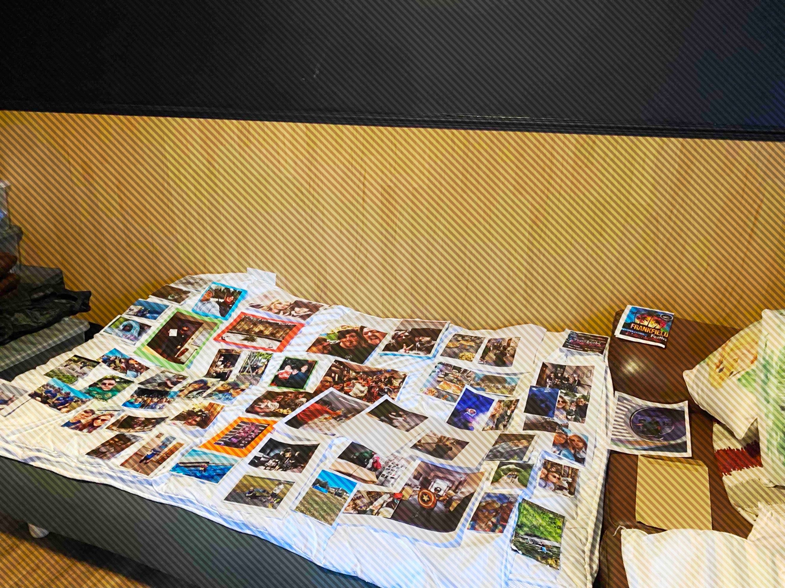

Meeting with [young person] happened ad hoc and was not recorded. Points that she made:

Did not want some pictures of her included as they were from a ‘difficult time’ in her life – [laughing] “any where I have black hair, that’s not a good sign”.

Didn’t mind the holiday pictures as they were ‘nice’. Wouldn’t mind pictures from today’s bake-off as that was ‘nice’.

Did not remember many of the photos being taken.

Said she does not have a good memory and that she does take pictures herself to remind her of things. Sometimes she posts these on Instagram – depends on the picture.

Does not think comments on the archive are a good idea because someone may ‘say something horrible on one of your pictures’.

Non-plussed about being able to interact with others. States the young people here don’t interact on social media platforms like Whatsapp.

Thinks only those who lived/worked there at the same time should be able to see photos of each other – ‘it would be weird if someone you don’t know is looking at your pictures’. Discussed in relation to [young person], who no longer lives here and she acknowledged that he is ‘like family’ and that would be fine.